**Karachi:**

Mohatta Palace

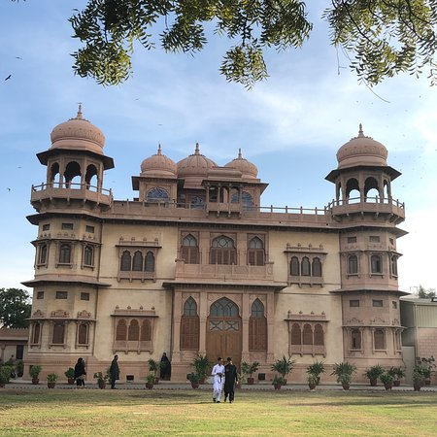

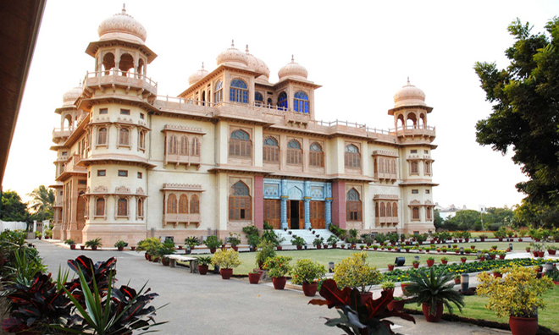

The **Mohatta Palace** is a museum located in Karachi ,Sindh, Pakistan. It was built in the posh seaside locale of Clifton by Shivratan Chandraratan Mohatta, a Hindu Marwari businessman from modern day Rajasthan in India, in 1927, as his summer home. The architect of the palace was Agha Ahmed Hussain. However, Mohatta could enjoy this building for only about two decades before independence, after which he left Karachi for India. He built the Palace in the tradition of stone palaces in Rajasthan, using pink Jodhpur stone in combination with the local yellow stone from Gizri. The amalgam gave the palace a distinctive presence in an elegant neighbourhood, characterised by Indo-Saracenic architecture which was located not far from the sea.